**PJ 3 Report My Name: __Yaowei Lei__**

**A. The following is my Python source program:**

**// Please copy your source program into here from your Visual Studio IDE.**

**// Your code here must be in color. You must not show screen prints here.**

#-------------------------------------------------------------------------------------------------.

# Author: Yaowei Lei

# Date: 10/24/2021

# Purpose: To play a game of rolling 2 dice between dealer and you, and win/lose money.

# MAIN PROGRAM: ====== Python does not use main( ) to start the main program.

#-------------------------------------------------------------------------------------------------.

import random # import library to use random.randint( )

n = 1 # line number for each separator line in sequence

print ("Welcome to the Rolling 2 Dice Game of Yaowei Lei!\n ") # ⬅ must use your name

print(n,"=========================================================."); n+=1; # increment n by 1

yourMoney = 100 # you have 100 dollars to start.

dealerMoney = 100 # dealer also has 100 dollars to start.

print( "Now, you have ", yourMoney, "dollars to play the game. Dealer also has ", dealerMoney, " dollars.")

bet = int(input("Enter your bet to roll 2 dice for this complete game (enter 0 to quit): ")) # convert to integer for bet

if bet == 0 :

exit( ) # to stop this game and exit immediately

while True: # keep running forever until break is encountered.

dealer = random.randint(1, 6) + random.randint(1, 6) # dealer rolls the dice twice to get 2 numbers

you = random.randint(1, 6) + random.randint(1, 6) # you roll the dice twice to get another 2 numbers

print(n,"=========================================================."); n=n+1;

print("Roll 2 dice twice: Dealer got ", dealer , ", and you got ", you , "." )

resaultWords = ["You won.", "You lost.", "It's tie."]

resault = " "

# if dealer > you: # dealerMoney will be increased by the bet, yourMoney will be deducted by the bet

if dealer > you :

yourMoney -= bet

dealerMoney += bet

resault = resaultWords[1]

# elif you > dealer: # - - -

elif dealer < you :

yourMoney += bet

dealerMoney -= bet

resault = resaultWords[0]

# else : # you == dealer # It is a tie.

else :

resault = resaultWords[2]

print(resault,"Now, You have ", yourMoney, " dollars, and dealer has ", dealerMoney, " dollars. ")

if dealerMoney <= 0 or yourMoney <= 0 : # either side has no money to play

break # time to exit the while loop and stop this game now. Game is really over.

# end of while True loop

print(n,"=========================================================."); n+=1;

print("Game ends. You have ", yourMoney, " dollars, and dealer has ", dealerMoney, " dollars. ")

print(n,"=========================================================."); n+=1;

print("Thank you for playing this Rolling 2 Dice Game of Yaowei Lei! ") # < < - - must use your name

print(n,"=========================================================."); n+=1;

x = input("Press Ctrl+Alt+PrtScn to get a snapshot of this console, then ENTER to exit: ")

# End of MAIN PROGRAM ============================================.

**B. The following is the console output of my 3 test runs:**

**// One way to copy the console output is to press Ctrl+Alt+PrtScn.**

**// Another way to copy is to use the snipping tool. To paste the image is to press Ctrl+v.**

**// The console display must not be too wide, otherwise it will be too hard to read once pasted.**

**// Please make sure your console is long enough to show all your output lines to be captured.**

**// Please copy your console output and paste into here:**

**Test Case #1: Bet must be 50.**

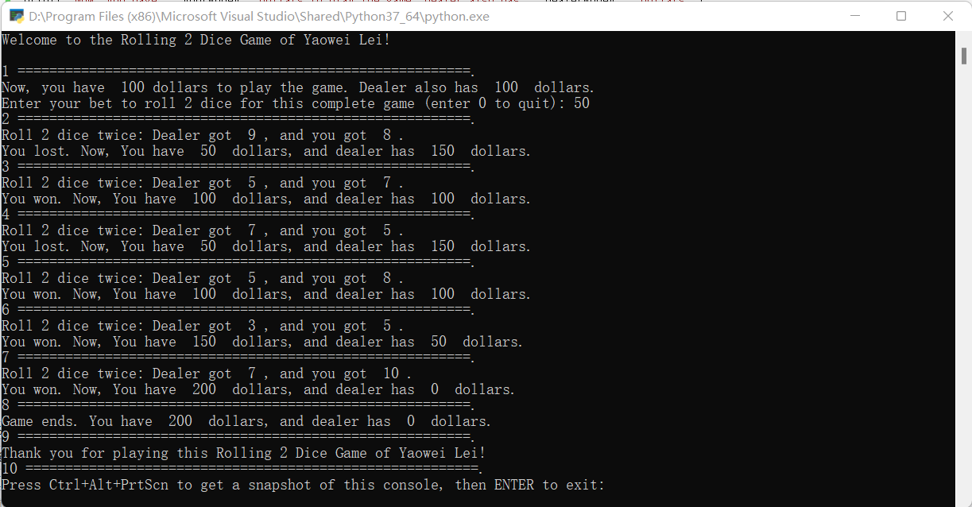

**Test Case #2: Bet must be 25.**

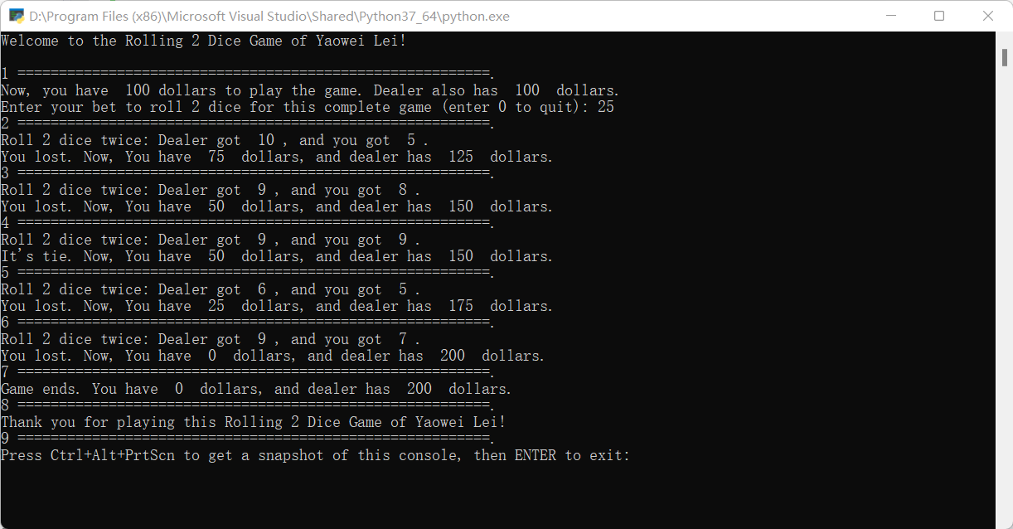

**Test Case #3: Bet must be 75.**

